23.74: Maximum speed occurs at “infinity” Energy conservation gives
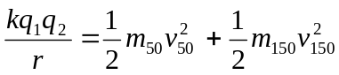
Momentum conservation: 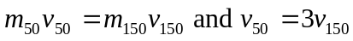
Solve for 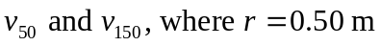
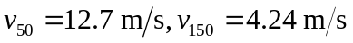
Maximum acceleration occurs just after spheres are released. 